Lab 6 – Coverage Analysis (Terminal Output Screenshots)

Code Coverage (Line) – Terminal Output
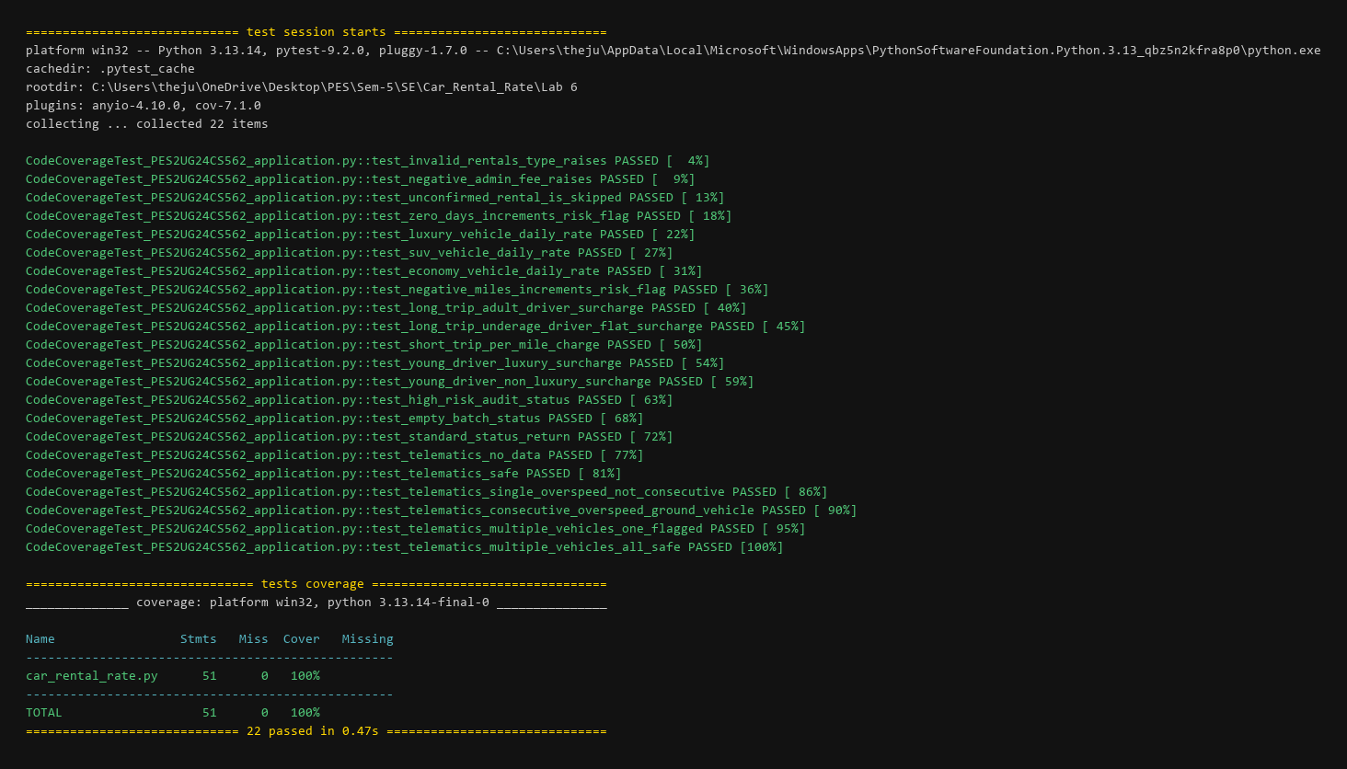

Branch Coverage – Terminal Output


